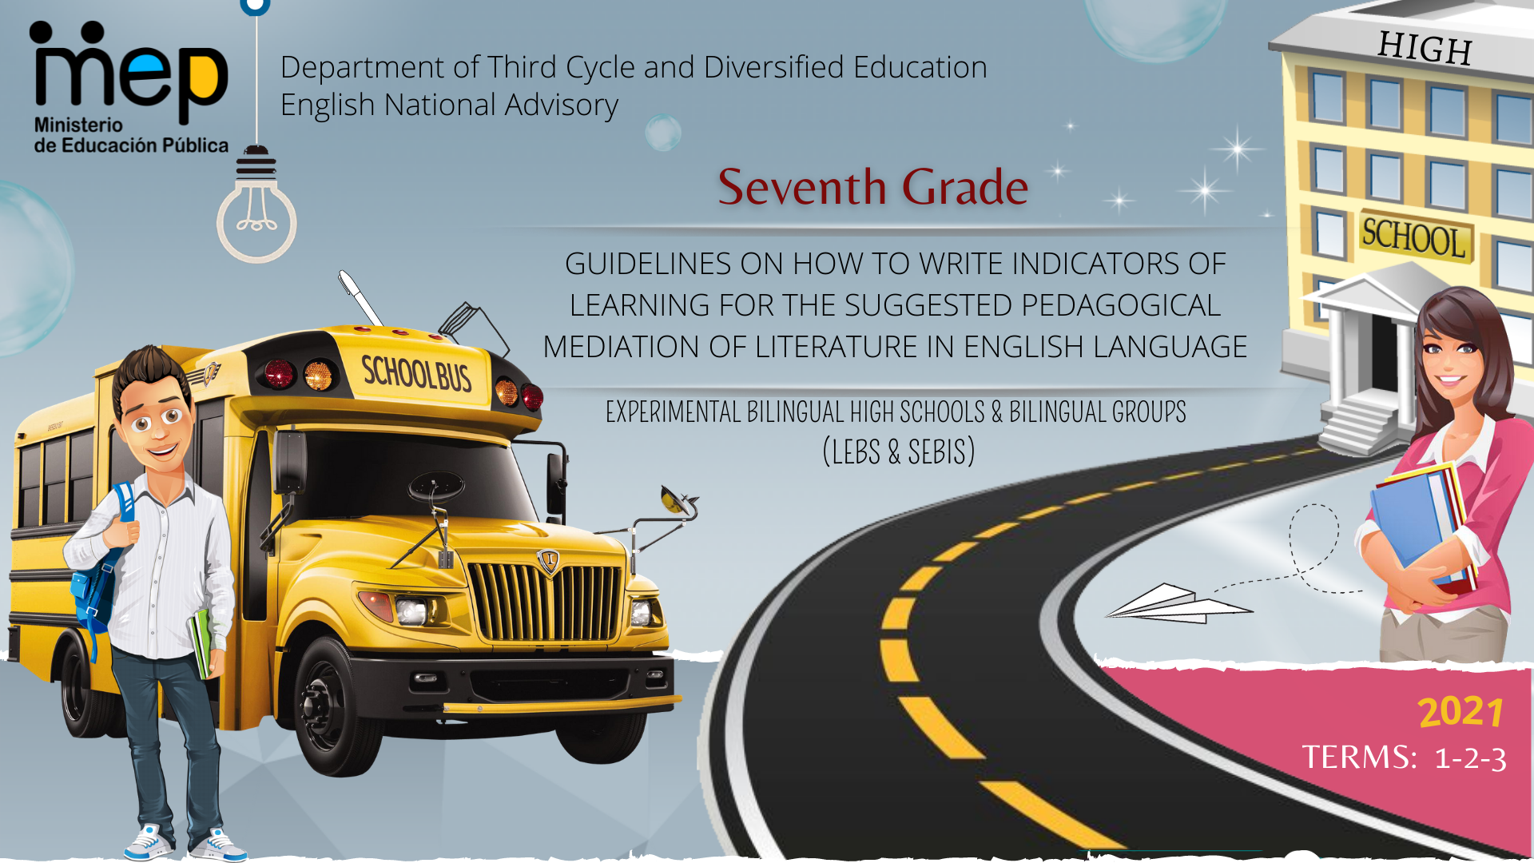

**Autoridades**

**Giselle Cruz Maduro**

Ministro de Educación Pública

**Melania Brenes Monge**

Viceministra Académica de Educación

**María Alexandra Ulate Espinoza**

Directora de la Dirección de Desarrollo Curricular

**Rigoberto Corrales Zúñiga**

Jefe del Departamento de Tercer Ciclo y Educación Diversificada

**Comisión redactora**

**Mag. Marianella Granados Sirias,**

Asesora Nacional de Inglés, Departamento de Tercer Ciclo y Educación Diversificada

**Mag. Alfredo Ortega Cordero**,

Asesor Nacional de Inglés, Departamento de Tercer Ciclo y Educación Diversificada

**Mag. Andrea Cruz Badilla**

Asesora Nacional de Inglés, Departamento de Tercer Ciclo y Educación Diversificada

**Comisión validadora**

Ivannia Arias Zúñiga. Sección Bilingüe Español-Inglés Liceo de Sinaí

Félix Díaz Castañeda, Sección Bilingüe Español-Inglés Liceo de Nicoya

Karen Pereira Meneses, Liceo de Costa Rica

Ana Lucía Ramírez Rodríguez, Liceo de Costa Rica

David Valerio Sánchez, Liceo de Costa Rica

Juliana Sánchez Sánchez, Sección Bilingüe Español-Inglés Liceo San Rafael

Roberto Segnini Cabezas, Sección Bilingüe Español-Inglés Liceo de Colorado

Luis Diego Soto Delgado, Sección Bilingüe Español-Inglés Liceo de Higuito

**Diseño de portada**

**Noelia González Cascante**

Dirección Regional de Educación Guápiles

**Table of Contents**

1. Presentation …………………………………………………………………………………………………………………….5
2. Aims of the document …………………………………………………………………………………………………….……5
3. Important points to keep in mind when working with the Literature in English Language Program……………………6
4. About the indicators for the pedagogical mediation ....................................................................................................8
5. 7th Grade Performance Indicators for the Pedagogical Mediation ………………………………………………………12
6. Important Considerations……………………………………………………………………………………………….…….13
7. Suggested Performance Indicators for the Pedagogical Mediation Term 1, 2, 3 ..……….………………….…..…....14
8. References …………………………………………………………………………………………………………..……..….18

**Presentation**

**Dear teachers:**

These guidelines intend to provide you, Literature teachers of seventh grade, with important information on how effectively write indicators to help you to plan your lessons and create assessment instruments for their Self-Study Guides (GTA) and the assessment promotion strategy or *estrategia de promoción* in Spanish. All the indicators will help teachers to measure the performance indicators set in the Literature in English Language curriculum. We believe that you know your students best and therefore we encourage you **to adapt and contextualize** what you find here so that it responds to the needs of your learners. Remember to visit the following link with supplementary resources for your lessons.  https://recursos.mep.go.cr/lebs_y_sebi/:

**Aims of this document:**

1. To give teachers a brief explanation on how to write indicators of learning for planning their Self-Study Guides (GTA in Spanish).
2. To recommend a list of suggested performance indicators for the pedagogical mediation to teach Literature in English Language in Seventh Grade.

Best,

English Secondary National Advisors

**Important points to keep in mind when working with the Literature in English Language Program.**

* Literature should connect with life experiences, beliefs, and convictions, which have to be faced through a methodological approach of ethical dilemmas (daily life, artistic, fictitious and historical) within a new democratic perspective.
* Literature constitutes a valid opportunity to promote the use of critical and creative skills in the process of building up a classroom community of inquiry, adapted by teachers, according to the learner´s interest and level of English.
* Literature is an invitation to a dialogue. It teaches about humanity and reveals pros and cons of characters in specific situations and times. Learning a language is also learning about culture and values.
* Literature mirrors our own lives and provides a window into distant places, times, and people.
* Reading literature can increase the chances of students becoming passionate readers, who read with a purposeful objective, as well as enjoyment. Additionally, students can improve other skills through literature. As an illustration, creativity and reflection can be reinforced as students perform, write, and analyze different literary texts. Perhaps, this is the ultimate reason that students have for writing with joy and pleasure; that is, their education will be going beyond the reading.

Taken from Programa de Literatura en Lengua Inglesa Liceos Experimentales Bilingües, 2011, MEP

**About the indicators for the pedagogical mediation…**

When working with the Literature in the English Language program, teachers need to design their own teaching procedures, in the mediation activities, on the basis of the learners’ pre-and post-assessments, as well as performance and reaction to instructional practices, circumstances and interests of each class community. The use of a rich variety of techniques and activities in the class will lead the students to establish positive cross curricular connections with suggested and flexible literature contents and within a socio-constructivist curricular approach. Consequently, visualizing, planning, and implementing techniques relevant to student-need and selecting coherent activities with the method, and in harmony with the approach, is the teacher’s job. In regard to the performance indicators for the pedagogical mediation, they are used to assess the activities proposed during the pedagogical mediation process. Performance indicators for the pedagogical mediation are strictly related to the activity’s achievement, and they help to provide specific and timely descriptive feedback to students.

It is important to clarify that this document includes only performance indicators that are measurable, observable and specific. However, we ask teachers to pay special emphasis on the following observable behaviors since they are as equally important because of nature and purpose of this subject:

* Appreciate and enjoy simple oral and written literature.
* Value different contributions from influential world leaders and writers.
* Demonstrate development of social strategies.
* Value authors´ literary contributions.
* Apply collaborative work and learning strategies (outline, graphic organizers, etc.).
* Use self-and co-assessment strategies.

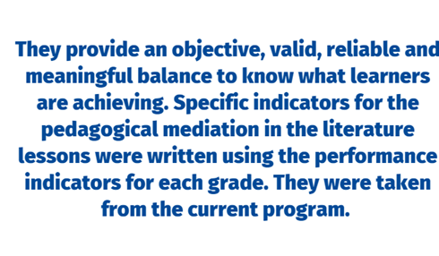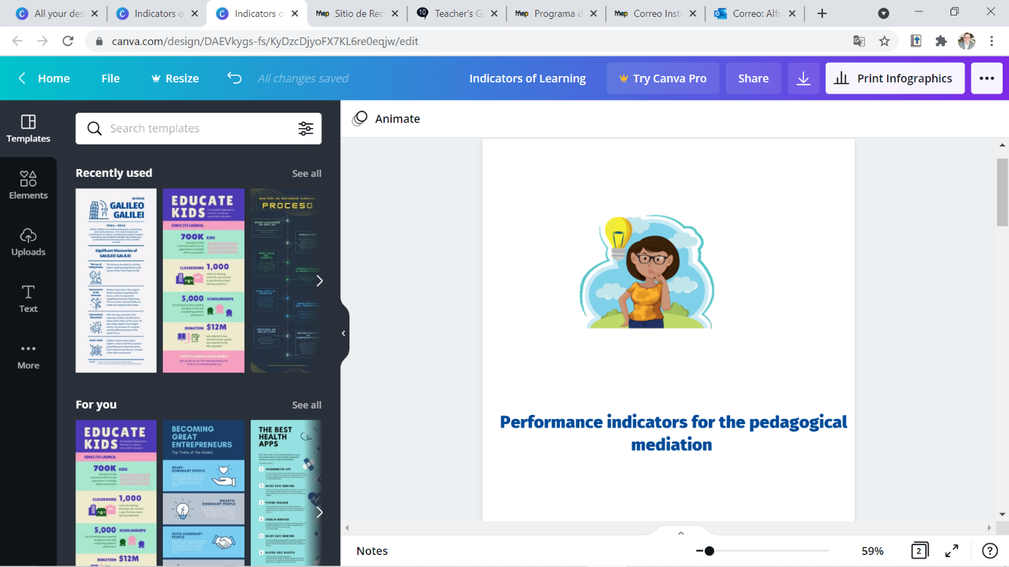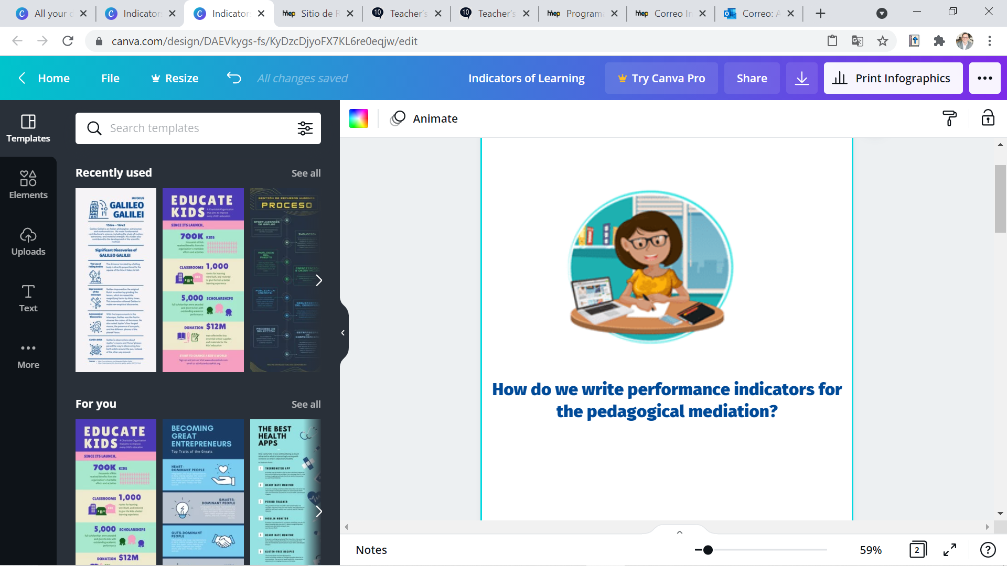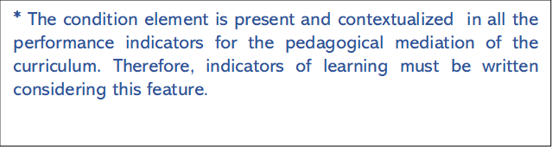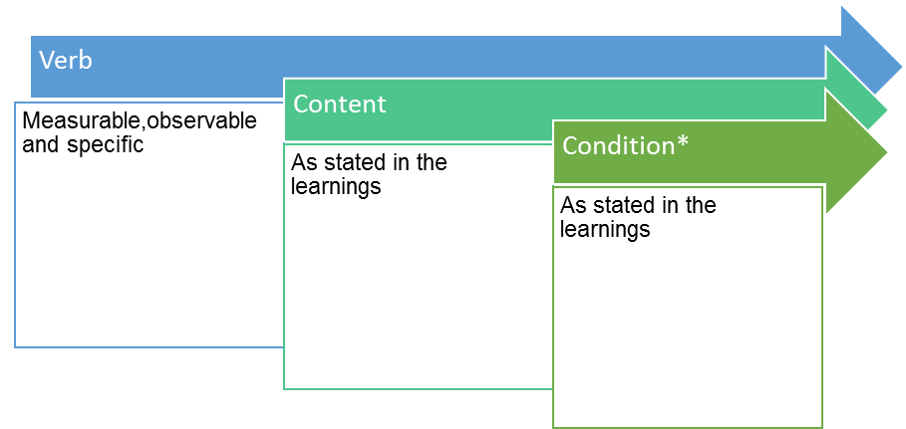

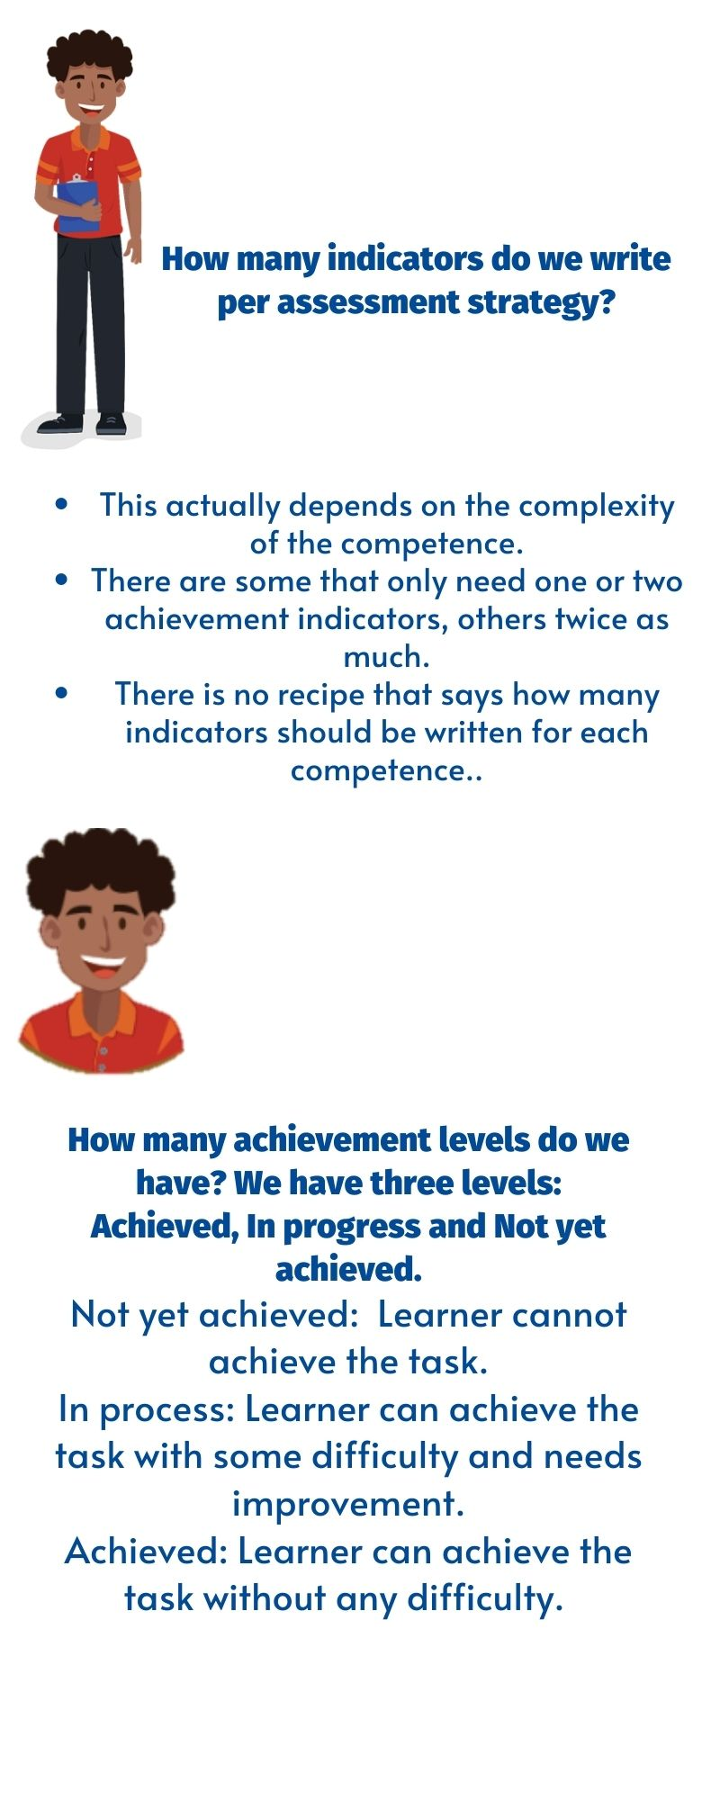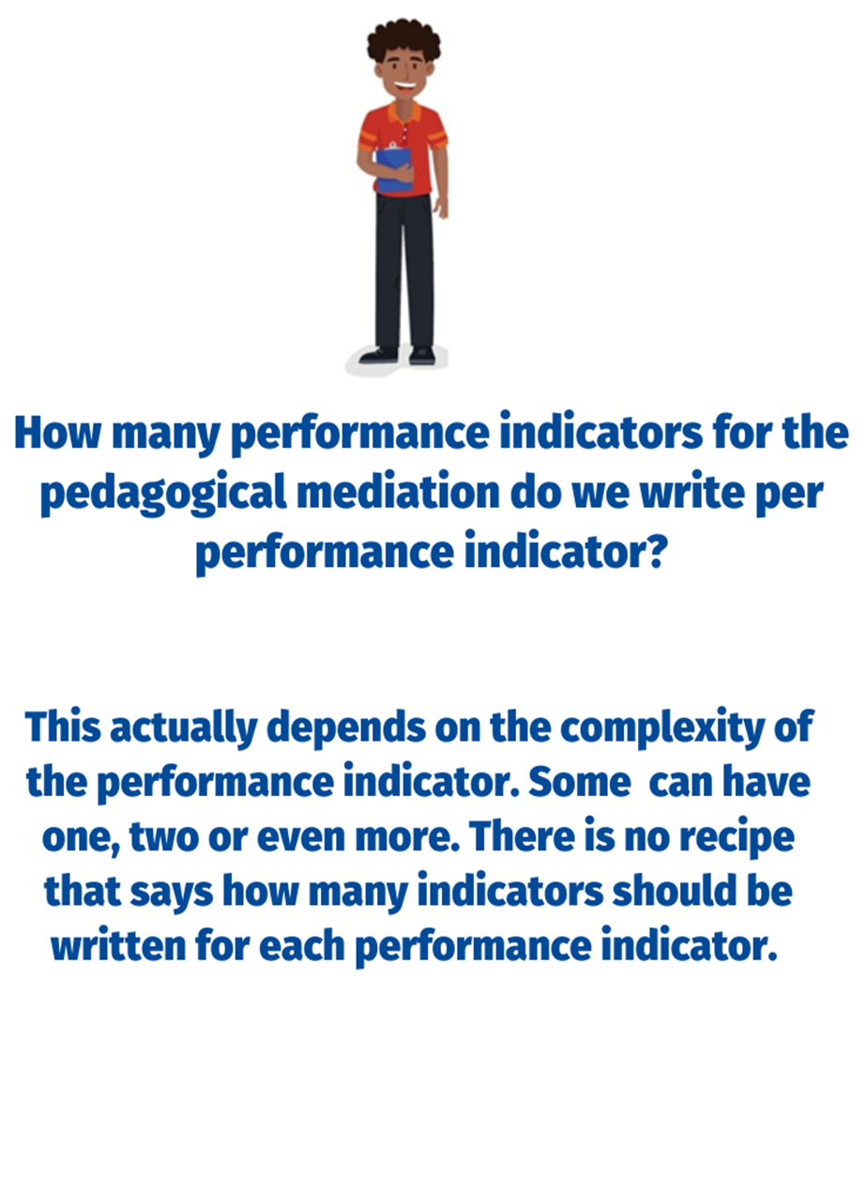

**7th Grade Performance Indicators for the Pedagogical Mediation**

The 7th Grade Literature in English Languagecurriculum provides performance indicators. These performance indicators are evidence that a teacher can record to show that students are achieving the learnings.

As classroom teachers, however, we do not simply assess students´ progress. We must guide students step by step through activities that enable them to reach the learnings.

This document breaks each performance indicator down into a number of specific performance indicators for the pedagogical mediation. They are the steps that learners follow to achieve the performance indicators. The performance Indicators for the pedagogical mediation have the following characteristics: measurable, observable and specific.

**How to use this document:**

1) Identify the performance indicator that you will be using.

2) Consider the steps or indicators for the pedagogical mediation learners need to follow to achieve each specific performance indicator.

3) Remember that there should be a connection between each performance indicator with the specific indicator for the pedagogical mediation proposed in this document.

4) Use specific indicators for the pedagogical mediation to monitor students’ progress and make the corresponding mediation changes if necessary.

**Important considerations:**

1. Indicators for the pedagogical mediation are organized in terms.
2. In some of the indicators proposed, teachers have to include the content of these indicators.
3. In most of the cases, indicators for the pedagogical mediation are arranged in a suggested order for students to perform them appropriately.
4. It is always necessary to use indicators for the pedagogical mediation, such as the ones suggested in this document. As educators, teachers must use their own professional judgement to identify the steps their students most need to take to achieve the learnings and that is reflected in the pedagogical mediation.
5. During the face- to- face and/or distance pedagogical mediation process, and therefore, at the end of each self-study guide, the teacher will use the indicators to create instruments (rubrics and /or performance scales) to assess students’ achievement level.
6. The mediation activities in the self-study guides must be coherent with the indicators for the pedagogical mediation to be included in the corresponding achievement level rubric.
7. When revising the indicators for the pedagogical mediation, consider that you can follow the steps below as suggested by the Institute of Collaborative Learning:

* **S**elect the activity and leave it as it is.
* **A**dapt it or change it somehow.
* **R**eject it. Choose not to use it
* **S**upplement it. Enrich the activity with extra material to make it more appropriate.

| Level: 7th  Terms: 1-2-3 | |
| --- | --- |
| Performance indicators from the program | Suggested Performance Indicators for the Pedagogical Mediation |
| Reacts to different oral and visual tasks (e.g., role plays, poems, songs, videos, dialogues and storytelling, etc.) | Identifies the title in role plays, poems, songs, videos, dialogues and storytelling. |
| Recognizes the author’s purpose by paying attention to the title. |
| Distinguishes images, techniques and literary figures. |
| Describes the artwork (oeuvre) including information about what, who, when, where, what it is about. |
| Reacts in a written / oral form towards the artwork (oeuvre). |
| Identifies some literary figures of speech (metaphor, simile, imagery, and symbolism). | Gets the gist of biographies, autobiographies, personal narratives, letters, diaries and journals, short stories, fables, and basic poetry. |
| Recognizes the structure of the different genres. |
| Identifies some literary figures of speech (metaphor, simile, imagery, and symbolism) in biographies, autobiographies, personal narratives, letters, diaries and journals, short stories, fables and basic poetry. |
| Produces humorous passages, letters, diaries, journals, and insights to express personal emotions. | Prewrites ideas for humorous passages, letters, diaries, journals, and insights to express personal emotions. |
| Drafts sentences for humorous passages, letters, diaries, journals, and insights to express personal emotions using the appropriate linkers or connecting words. |
| Revises a short, simple text by checking written sentences to look for mistakes related to subject-verb agreement, capitalization, spelling, and basic punctuation) and content. |
| Edits humorous passages, letters, diaries, journals, and insights to express personal emotions by correcting the mistakes before publishing them. |
| Narrates meaningful life experiences. | Sets the scene of a meaningful life experience. |
| Describes the problem/ situation of a meaningful life experience. |
| Lists the rising actions of a meaningful life experience. |
| Distinguishes the climax of a meaningful life experience. |
| Describes falling action of a meaningful life experience. |
| Explains a resolution of a meaningful life experience. |
| Identifies humor. | Gets the gist of passages, letters, diaries, journals and personal narratives. |
| Recognizes the different humor forms in passages, letters, diaries, journals and personal narratives. |
| Writes basic poetry: cinquains, haikus, epigrams, and song lyrics. | Prewrites lines for cinquains, haikus, epigrams, and song lyrics. |
| Drafts lines for cinquains, haikus, epigrams, and song lyrics. |
| Revises lines in cinquains, haikus, epigrams, and song lyrics. |
| Edits cinquains, haikus, epigrams, and song lyrics by correcting the mistakes before publishing them. |
| Identifies some elements of fiction (characters, plot, setting, point of view). | Gets the gist of role plays, videos, songs and storytelling. |
| Recognizes the structure of role plays, videos, songs and storytelling. |
| Identifies some elements of fiction (characters, plot, setting, point of view, theme, climax, resolution)in role plays, videos, songs and storytelling. |
| Gets meaning in different contexts. | Identifies written and spoken forms of vocabulary in different literary passages. |
| Recognizes the different meanings of the same word by using the context in different literary passages. |
| Expresses ideas, feelings, likes and dislikes, preferences, and opinions using appropriate vocabulary in oral and written forms. | Plans a set of ideas to express ideas, feelings, likes and dislikes, preferences, and opinions using appropriate vocabulary in oral and written forms towards the artwork (oeuvre). |
| Makes complete sentences to express ideas, feelings, likes and dislikes, preferences, and opinions using appropriate vocabulary in oral and written forms towards the artwork (oeuvre). |
| Predicts events and consequences in different literary passages. | Foretells events in different literary passages. |
| Foretells consequences in different literary passages. |
| Questions events and consequences in different literary passages. | Identifies facts from events in different literary passages. |
| Recognizes details from the events and consequences. |
| Inquires the relationship between events and consequences in different literary passages. |
| Infers events, consequences in different literary passages. | Gets the gist of an event in different literary passages. |
| Identifies main ideas in different literary passages. |
| Recognizes specific details of an event different literary passages. |
| Establishes connections and links among the gist, main ideas and details. |
| Draws conclusions about the consequences of an event based on connection and links in different literary passages. |

Propuesta elaborada por: Marianella Granados Sirias, Alfredo Ortega Cordero, Andrea Cruz Badilla. Asesores Nacionales de Inglés. **Departamento de Tercer Ciclo y Educación Diversificada. Dirección de Desarrollo Curricular**

**References**

Common European Framework of Reference for Languages: Learning, Teaching, Assessment (2003). Cambridge, U.K.: Press Syndicate of the University of Cambridge.

Common European Framework of Reference for Languages: Learning, Teaching, Assessment (2018). Cambridge, U.K.: Press Syndicate of the University of Cambridge.

Ministerio de Educación Pública (2021). Lineamientos técnicos para el proceso de evaluación, curso lectivo 2021. San José, Costa Rica: MEP.

Ministerio de Educación Pública (2021). Mediación Pedagógica para la Educación Combinada, curso lectivo 2021. San José, Costa Rica: MEP.

Ministerio de Educación Pública (2011). Programa de Estudio de Literatura en Lengua Inglesa Liceos Experimentales Bilingües. San José, Costa Rica: MEP.

https://www.orientacionandujar.es/2016/11/06/taxonomia-robert-marzano-verbos-recomendados-indicadores-niveles-cognitivos/